N1)

Code:

var http = require('http');

http.createServer(function(req, res) {

    res.writeHead(200, { 'Content-Type': 'text/html' });

    res.end('Hello World!');

}).listen(8080);

Output:

N2)

Code: app.js

var http = require('http');

var dt = require('./myModule');

http.createServer(function(req, res) {

    res.writeHead(200, { 'Content-Type': 'text/html' });

    res.write("The date and time are currently: " + dt.myDate());

    res.end();

}).listen(8080);

Code: myModule.js

let myDate = function() {

    return Date();

};

exports.myDate = myDate;

Output:

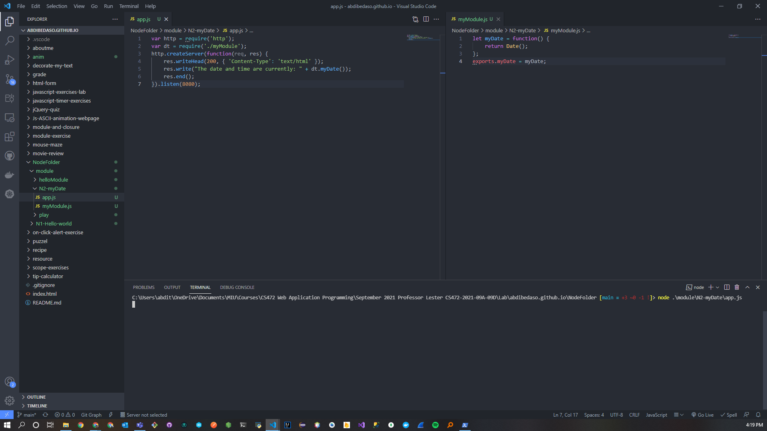

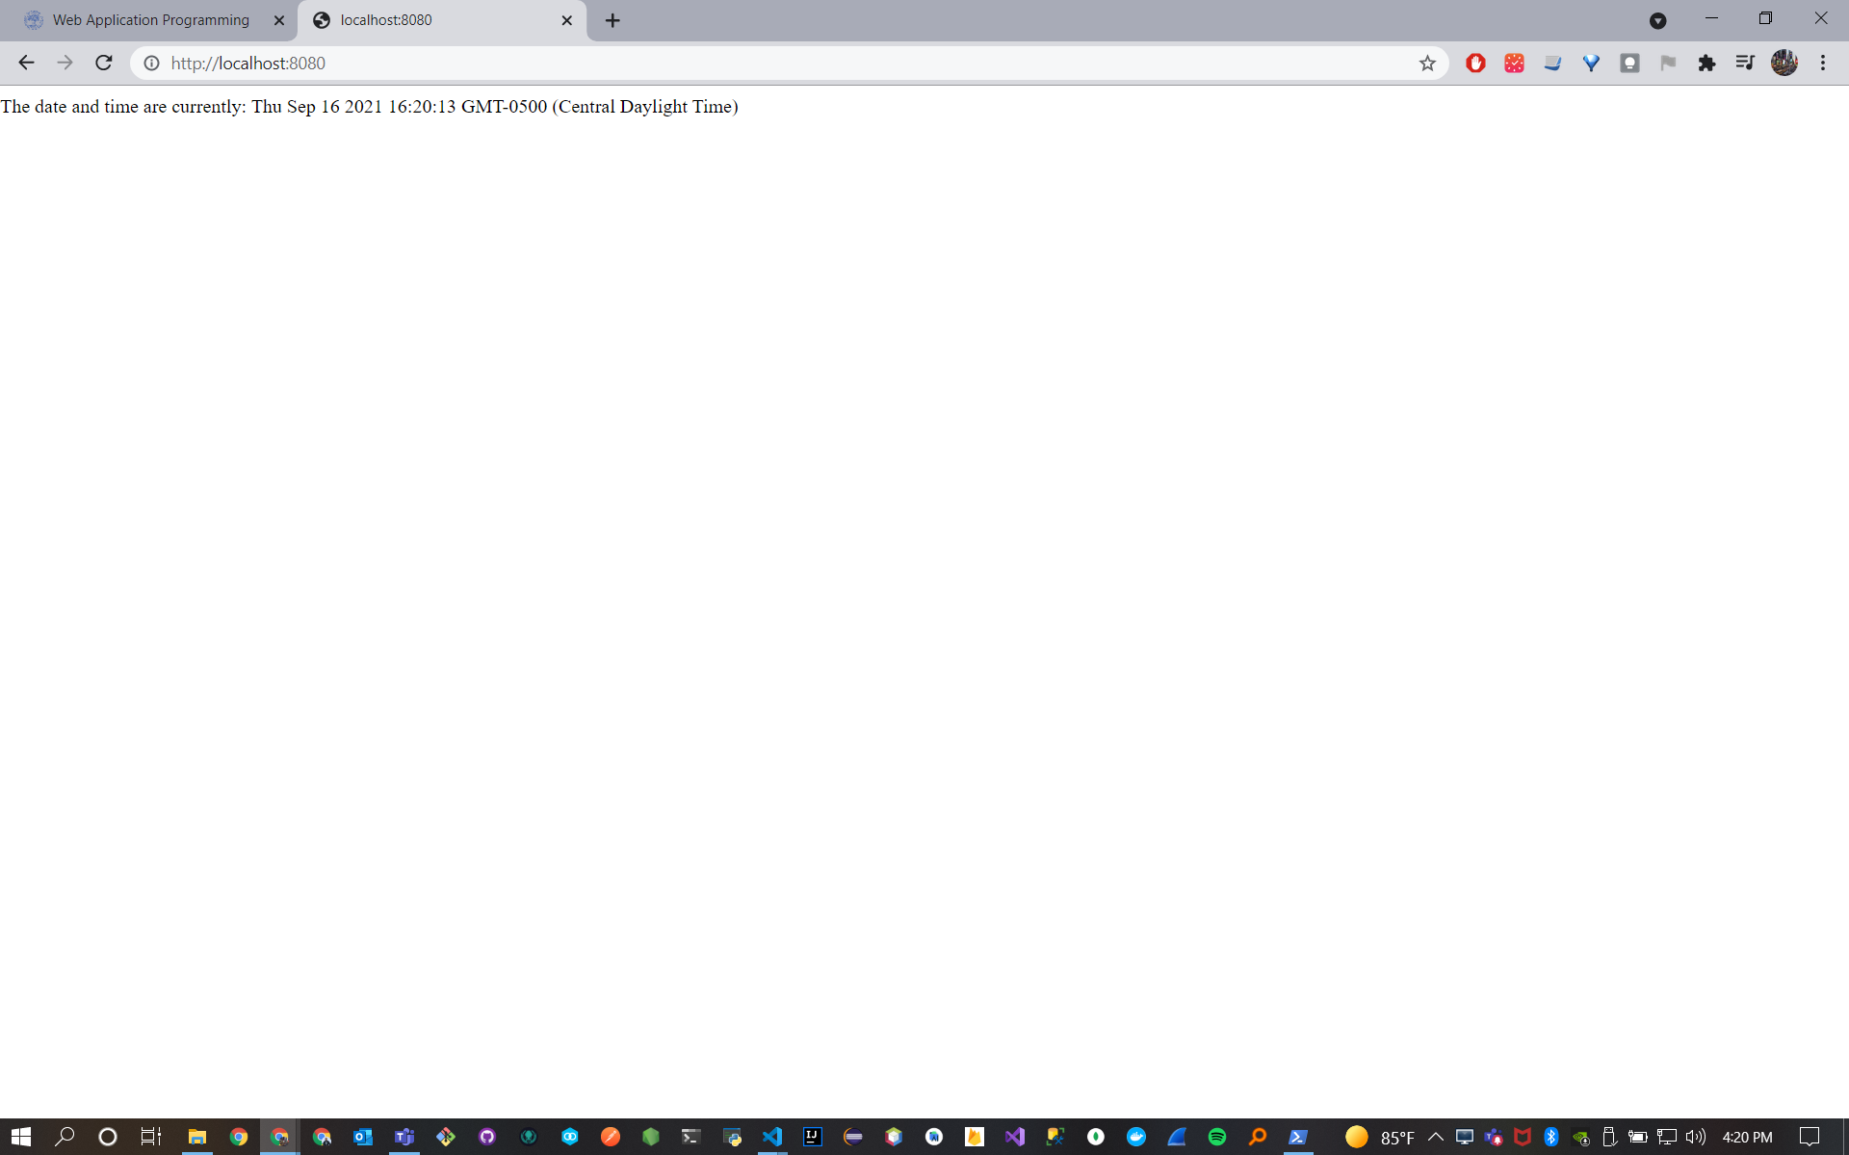

N3)

Code: app.js

var http = require('http');

http.createServer(function(req, res) {

    res.writeHead(200, { 'Content-Type': 'text/html' });

    res.write(req.url);

    res.end();

}).listen(8080);

Output:

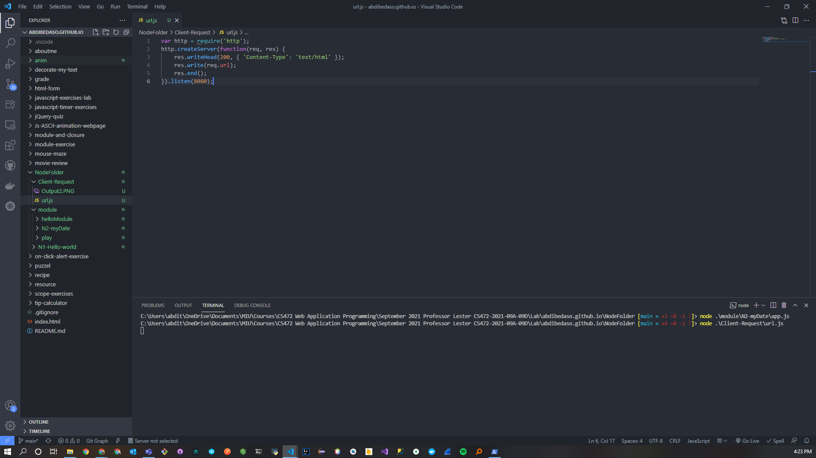

N4)

Code: AdderWebServer.js

var http = require('http');

var url = require('url');

var fs = require('fs');

var addmod = require('./addmod.js');

http.createServer(function(req, res) {

    var q = url.parse(req.url, true);

    var filename = "." + q.pathname;

    if (q.pathname == "/add.js")

        addmod.add(req, res, q.query)

    else

        fs.readFile(filename, function(err, data) {

            if (err) {

                res.writeHead(404, { 'Content-Type': 'text/html' });

                return res.end("404 Not Found");

            }

            res.writeHead(200); *// Content-Type not included*

            res.write(data);

            return res.end();

        });

}).listen(8080);

Code: addmod.js

exports.add = function(req, res, vals) {

    var sum = parseInt(vals.first) + parseInt(vals.second);

    res.writeHead(200, { 'Content-Type': 'text/html' });

    res.write(`<!DOCTYPE html>

    <html>

    <head><meta charset=\"utf-8\"/>

    <title>Calculator Web Site</title>

    </head>

    <body>

    <p>The sum is: ${String(sum)}</p>

    </body>

    </html> `);

    return res.end();

};

Code: SimpleAdder.html

<!DOCTYPE html>

<html lang="en">

<head>

    <meta charset="UTF-8">

    <meta http-equiv="X-UA-Compatible" content="IE=edge">

    <meta name="viewport" content="width=device-width, initial-scale=1.0">

    <title>Simple Adder</title>

</head>

<body>

    <form action="http://localhost:8080/add.js">

        <div>Enter two numbers

            <input type="text" name="first" /><br/>

            <input type="text" name="second" /><br/>

            <input type="submit" value="Click" />

        </div>

    </form>

</body>

</html>

Output:



